
Global Leaders in creasing technology
Eliminating fibre cracking 100%

October 2009

World Class Print Finishing Advice & Product Updates

Tech-ni-Fold has hit on something really special
for the Digital Creasing Market

The new CreaseStream^{Plus} is the first solution that presents a serious alternative to those Rule and Matrix machines

Tech-ni-Fold is proud to announce the introduction of a very special product that is set to revolutionize the way litho and digital print is finished, and that will present a serious alternative to the fleet of Rule and Matrix machines that, up until this point, seemed to have dominated the market.

The modular built and highly versatile CreaseStream^{Plus} is the culmination of 10 years creation, development and evolution by Tech-ni-Fold, which incorporates our very latest patented creasing and micro-perforating technology. The Plus in the machine’s name represents the multitude of extra applications and benefits it brings, other than just creasing. For more information see the article overleaf.

Graham Harris, Managing Director, Tech-ni-Fold Ltd

The reason: for this type of fold, the scores are typically very strong, and once you get it set close to the score, the sheet wants to fold on the score. It may do so for a few sheets or even a few hundred sheets.
So although the folder may seem to be set, one plate just slightly off can have an intermittent impact on folding, and one or more folds can be affected without any apparent rhyme or reason.
The Solution:
1. Before running any of the "live" pre-scored sheets, cut down sheets of single thickness stock to the exact same size of the piece as it is coming out of the first section. If you're already running a single sheet cover stock, just cut down text stock to the same size.
2. Re-set the fold roller calipers.
3. Hand feed one sheet at a time, and set fold plates, one at a time. Be sure they are folding consistently and squarely.
4. Re-set fold roller calipers to the live job. Run several sheets of the live job. It should fold perfectly.
It's an extra step that takes perhaps 10 minutes to accomplish, but it's saved me countless hours of troubleshooting time over the years, and I'm sure it will do the same for you.

For More Information and Tips
Call Paul Barrett on 01455 554491

Tech-ni-Tip

How to Get Better Right Angle Accordion Folds

The Problem: Broadside accordion folds, or single sheet accordion folds on cover stock, each require scoring in the first section before the right angle fold. (By broadside, I'm referring to a fold in 1/2 in the first section, then in to multiple panels in the right angle.) Each score must line up precisely with the fold, and each fold plate must be set to create equal size panels.
Of course all the scores must
be set up exactly right and
must register. If you don't
have that to start with, you'll
fight the quality all day long.

(A quick old-timer tip for
making the scores visible...
apply a dark crayon or felt tip
marker to the score blade or
insert. This makes the score
visible and it wears off after
several sheets.)

Once the scores are set, the operator usually sets the
right angle folds with the scored sheets. As soon as the fold plate appears to be set correctly, they'll move on to the next plate. However, it's not surprising to find that the actual fold plate setting can be up to 1/4" away from the score!

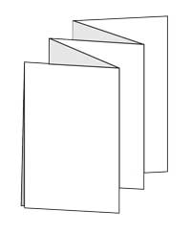

www.technifold.com

At Last, A New Digital Creasing & Folding
Revolution Has Arrived

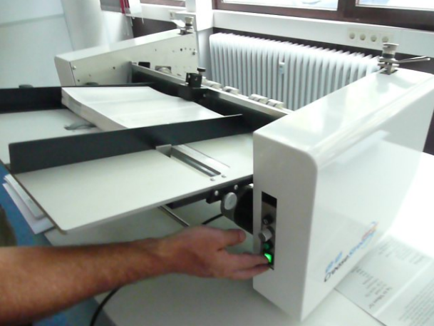

Amazing In-Line & Off-Line Folding Options

What makes our innovative machine even more exciting is the fact that we have created 2 special folding stations to complete the finish, and that can deal with sensitive digital stocks up to 350gsm. The in-line folding station is a simple add-on unit that allows continuous production at speeds of up to 18,000 sheets per hour. The off-line folder can be set up as a second step operation and can produce up to 25,000 folded products per hour.

Lower Price Makes A Big Difference

We believe our customers should receive great value for the money they spend. This is why we will cap the price throughout the world so that you can become part of the new Tech-ni-Fold print finishing revolution, without breaking the bank.

Here is a list of what the CreaseStream^{Plus} can do:

- Totally eliminate fibre cracking, even on digital stocks, regardless of grain direction, at up to 18,000 sheets per hour.
- Choose from any one of 9 crease styles to suit every range of stock, not restricted to wide setting.
- Produce simultaneous multiple crease, micro-perf without affecting speed.
- Apply crease or micro-perfs to either side of sheet, or both at the same time.
- Produce flat, nearly invisible micro-perforations that let sheets run through any laser printer or copier.
- Crease paper from 85gsm through to 350gsm and above.
- Finish short-run jobs in minutes.
- Eliminate scoring and perf out-sourcing.
- Build as you go, start basic and add-on on optional tools and fold units.

For a CreaseSteam^{Plus} brochure and price information please call us on 01455 554491

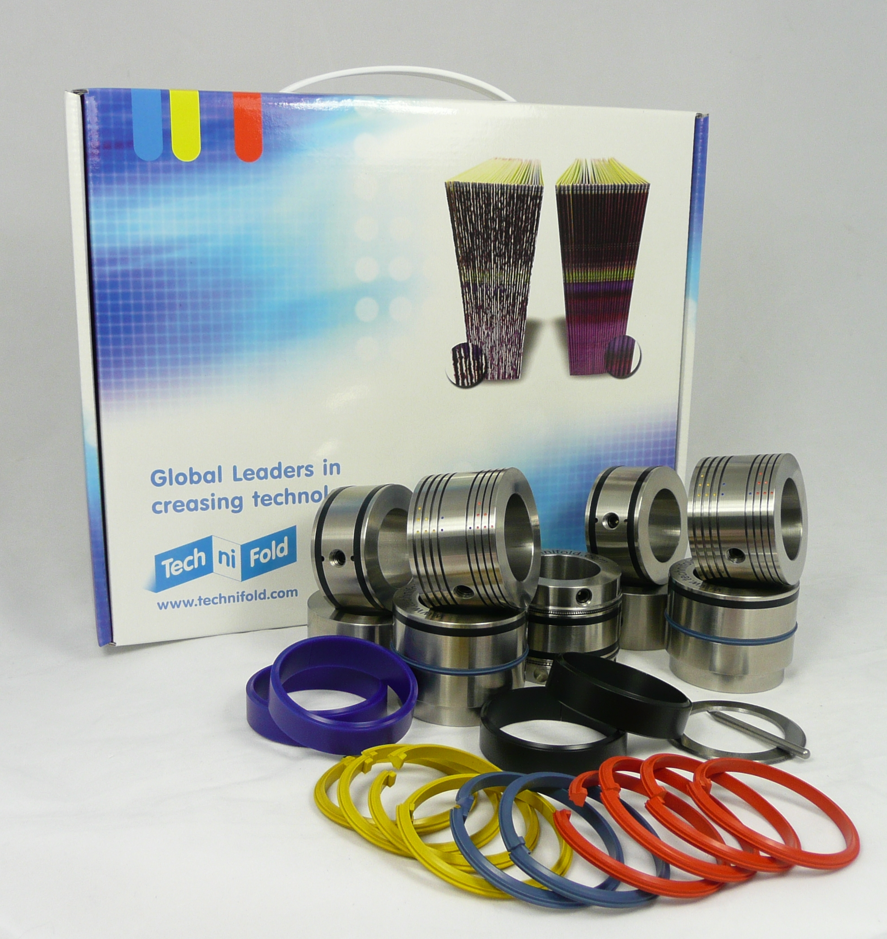

Tech-ni-Tip

Pick That Rubber Band Off the Floor and Put it On Your Folder...

Maybe it's a tie between duct tape and the rubber band - both get top billing
in the home-grown fix-it category. Here's one use for a rubber band that's
as simple as it is effective.

This applies to machines using a drum-type vacuum wheel in the feeder
(either continuous or pile fed) as shown here and which is common to most
popular folders.
The Problem: pulling double sheets on uncoated stocks, especially light
weight text. Precise control of vacuum is difficult with light stocks.
As we've mentioned before with regard to feeding on stitchers, reducing
vacuum often results in no feed at all, or lots of double sheets feeding.
Unlike with stichers, a double feed means a machine stop and possibly a
wasted sheet.

The Rubber Band Solution: simply put a rubber band around the
vacuum drum (shown in red above) and readjust the vacuum. It’s not a
sure-fire problem eliminator, but it can turn a problem job into a
manageable job.

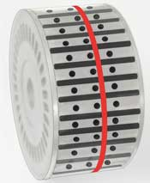
Copyright
Tech-ni-Fold Ltd, Unit 2,
St John’s Business Park, Lutterworth, Leicester
LE17 4HB

Tel: +44 (0) 1455 554491
Fax: +44 (0) 1455 554526

Copies of this newsletter may be distributed to anyone in the print industry.
No part of it however can be changed unless approval is granted in writing by
Tech-ni-Fold Ltd.

www.technifold.com

